Canadian Weightlifting Federation

Haltérophile Canadienne (CWFHC)

Competition Introduction Planning Tool
For evaluation and beyond

Context: Competition Introduction

© This document is copyrighted by the Coaching Association of Canada and Canadian Weightlifting Federation Haltérophilie Canadienne (CWFHC) and its licensors. All rights reserved.

Collection, use and disclosure of personal information
“The Coaching Association of Canada collects your NCCP qualifications and personal information and shares it with all NCCP partners according to the privacy policy detailed at www.coach.ca.

By participating in the NCCP you are providing consent for your information to be gathered and shared as detailed in the privacy policy. If you have any questions or would like to abstain from participating in the NCCP please contact coach@coach.ca.”

Acknowledgments
The CWFHC would like to acknowledge the following people for their contribution in the development of this document:
- Dr. François Gravelle Ph.D. (CWFHC),
- Ms. Jill Miller (CWFHC), and
- Mr. Anthony Bhagwandin (CAC).

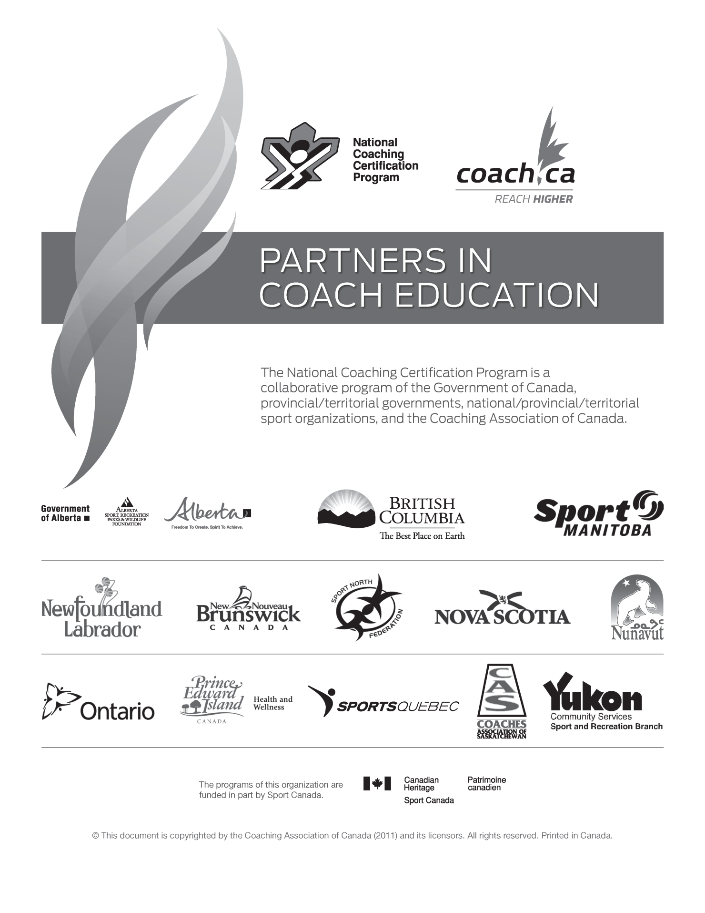

Table of Contents
Canadian Weightlifting Federation 1
Haltérophile Canadienne (CWFHC) 1
CWFHC Competition Introduction Coach Evaluation 6
Step 1: Coach Profile: 7
Step 2: Athlete Profile: 8
Step 3: Demonstrate Application of Learning (Analyze Performance) 9
Step 4: Demonstrate application of learning: Support the Athletes in Training 10
Step 5: Design an emergency action plan (EAP) 11
Step 6: Demonstrate Application of Learning (Support the Competitive Experience) 15
Step 7: Submit your planning tool as directed for analysis and review 17
Step 8: Present your athlete at an accredited competition for competency evaluation 17
Step 9: Provide proof that you have passed the Make Ethical Decisions on-line evaluation 17

CWFHC Competition Introduction Coach Evaluation
This submission provides you with the opportunity to demonstrate the practical application of the concepts as presented in the Competition Introduction Course in the following modules:
- Analyze Performance
- Support the Athlete in Training
- Support the Competitive Experience
You will find a copy of the evaluation matrices and the Competition Introduction Certification Pathway in your course manuals.

Step 1: Coach Profile:
Please fill out your coach profile, as it will provide the evaluator with valuable information on yourself in view of your evaluation.
Coach Profile Form
Name |  |  |  |  |  |  | NCCP No.
 | Family Name |  |  | First Name
Address
 | Apt. | Street
 | City |  |  |  | Province |  |  |  | Postal Code
Phone | ( ) |  |  |  | ( ) |  |  |  | ( )
 | Home |  |  |  | Business |  |  |  | Fax
E-mail
Number of years coaching
Primary LTAD stage of athlete coached
Name of club
Head coach
Coaching Context Description
Number of athletes |  |  |  |  |  | Average practice time
Youngest athlete’s age (y) |  |  |  |  |  | Number of practices/week
Oldest athlete’s age (y) |  |  |  |  |  | Number of weeks/year
Checklist
Item |  |  |  |  |  |  |  | Yes |  | Date (dd/mm/yyyy)
Step 1: Coach Profile
Step 2: Athlete Profile
Step 3: Demonstrate Application of Learning (Analyze Performance)
Step 4: Demonstrate application of learning: Support the Athletes in Training
Step 5: Design an emergency action plan (EAP)
Step 6: Demonstrate Application of Learning (Support the Competitive Experience)
Step 7: Submit your planning tool as directed for analysis and review
Step 8: Present your athlete at an accredited competition for competency evaluation
Step 9: Provide proof that you have passed the Make Ethical Decisions on-line evaluation

Step 2: Athlete Profile:
Provide us with a profile of your athlete, as this information will help the evaluator appreciate the specificities of your 4 weeks training program.
Athlete Profile Form
Name: | Age | Gender | Weight Class
LTAD Stage and training age in weightlifting
How long has the athlete trained with you?
General athletic training background of your athlete (e.g. other sports played)

Strengths and weaknesses related to weightlifting

Additional Information

Step 3: Demonstrate Application of Learning (Analyze Performance)
Describe one area in your athletes learning of the Snatch or Clean and Jerk where your athlete has challenges and outline the assistance exercise you used to address this challenge.
Area of concern (please describe) | Assistant exercise(s) | Results

Step 4: Demonstrate application of learning: Support the Athletes in Training
Based on the athlete presented above, describe and justify three basic, weightlifting-specific training principles that you will use to create a four week pre-competition program for them:
Principle | Justification | Expected results
1)

2)

3)

Step 5: Design an emergency action plan (EAP)
Please submit a copy of your Emergency Action Plan as trained in NCCP Multi-sport module “Plan a Practice”. This plan is what you will use during your training sessions with your athlete.

Preparing an Emergency Action Plan (EAP) in advance will help you respond responsibly and calmly in an emergency.
Your EAP should be prepared for the facility or site where your practices normally take place or for any facility or site used for special training sessions. An EAP can be simple or elaborate. It should cover the following items:
- Advance designation of the person in charge in an emergency (this may be the coach).
- A fully charged cell phone. If this is not possible, specify the location of a pay phone and have spare change available.
- Emergency telephone numbers (facility manager, fire, police, ambulance), as well as contact numbers (parents/guardians, next of kin, family doctor) for athletes.
- A medical profile for each athlete that can be given to emergency medical personnel. Include a signed consent from the parent/guardian authorizing medical treatment in an emergency.
- Directions to the site for Emergency Medical Services (EMS) so they can reach the site as rapidly as possible. Include information such as the closest major intersection, one- way streets, and major landmarks.
- An accessible and properly stocked first aid kit (all coaches are strongly encouraged to pursue first aid training).
- Advance designation of a call person who contacts medical authorities and assists the person in charge. The call person should be able to provide precise instructions to drivers of emergency vehicles so that they can reach the facility as quickly as possible.
Use the templates on the following to prepare your EAP

Emergency Action Plan
Emergency Phone #s | 911  Coach: Tel: ( )  Coordinator: Tel: ( ) | Checklist  - Location of telephones is identified.  - Emergency telephone numbers are listed.  - Cell-phone battery is charged.  - Change is available to make phone calls from a pay phone.
Facility Address | Address of training site:  Address of Nearest Hospital: | Directions  Accurate directions to site:
Charge Person | Name: Tel: ( )  Alternate 1: Tel: ( )  Alternate 2: Tel: ( ) | Roles and Responsibilities:
Call Person | Name: Tel: ( )  Alternate 1: Tel: ( )  Alternate 2: Tel: ( ) | Roles and Responsibilities:
Participant Information
First Aid Kit

Medical Information
Athlete Name:
Birth Date (dd/mm/yyyy) |  |  |  | Age |  | Male □ | Female □
Address |  | Street
 |  | City | Province |  |  | Postal Code
Health Insurance Number
Names of Parents/Guardians
Address
 |  | Street
 |  | City | Province |  |  | Postal Code
Telephone
 |  | Home | Work |  |  | Cell
Family Doctor
 |  | Name |  |  |  | Phone
Health History |  | Details:
Allergies | Yes _ No _
Asthma (Respiratory) | Yes _ No _
Blackouts/ Fainting | Yes _ No _
Chest pain | Yes _ No _
Diabetes | Yes _ No _
Epilepsy | Yes _ No _
Hearing disorder | Yes _ No _
Heart condition | Yes _ No _
Recurring headaches | Yes _ No _
Seizures | Yes _ No _
Glasses | Yes _ No _
Contact lenses | Yes _ No _
Injuries (specify) | Yes _ No _
Medications (specify) | Yes _ No _
Other (including recent surgery) | Yes _ No _

Step 6: Demonstrate Application of Learning (Support the Competitive Experience)

Outline of the evaluation process
Prepare your athlete for his or her first Olympic Weightlifting Competition:
- Outline what you will be addressing with your athlete to prepare him or her to attend the competition.
Present a 4-week pre-competition training plan which culminates in the athlete being ready to compete in their first competition.
Your submission should be on no more than 5 pages.
Notes:
- Use the Excel template to complete this step and outline your 4-week training program
- Athletes should train 3 days per week maximum
- The primary focus of training should be the Snatch and Clean and Jerk
- Assistance exercise(s) included should address the challenges identified above for the athlete
- The athlete should engage in a “mock completion”, at some point in the 4 weeks and practice the warm-up procedure at this time
- The final week should be a taper week with a reduced load and intensity
- You should review with the athlete what to expect at the competition, including:
  - The weigh-in procedure, and
  - Warm-up and timing.

Training Plan
- Days of training e.g., Mon, Wed, Fri,
- List of exercises: 3-4 e.g. Snatch, Clean, Clean Pulls, Front Squat
- The sets and reps (e.g. volume) you are going to do for each exercise
- What weight the athlete will be lifting (e.g. intensity) for each repetition
Please refer to the Support the Competitive Experience module for further reference

Competition Performance Planning
- Best lifts at start of 4 week program: Snatch Clean and Jerk
- Competition performance goals Snatch Clean and Jerk
- Planned warm up for both the Snatch and Clean and Jerk
- Planned mental strategies for effective competition
- Planned attempts: 1st 2nd & 3rd for both Snatch and Clean and Jerk

Note 1: You have a sample warm up plan in the Support the Competitive Experience module.

Note 2: Please ensure you review the material in Support the Competitive Experience as to how you should interpret the “Start List”, to know when your athlete will start lifting at the competition

Step 7: Submit your planning tool as directed for analysis and review

Step 8: Present your athlete at an accredited competition for competency evaluation
- Ensure that the name, location, and date of the competition is actually recorded somewhere in the Competition Plan

Step 9: Provide proof that you have passed the Make Ethical Decisions on-line evaluation
Do the following in the order specified:
- Participate in the Make Ethical Decisions multi-sport training module. This module is available through provincial or territorial Coaching Associations. The evaluation can be completed without taking the course but the Make Ethical Decisions (MED) module online at www.coach.ca will increase your familiarity with the NCCP ethical decision-making process.

- Complete the on-line evaluation (Competition - Introduction) MED online evaluation, to do this go to www.coach.ca and follow the directions. This page provides all of the information needed to complete the evaluation.

- Access your transcript in The Locker, and provide a copy of it as part of your submission. It will include a record of your successful completion of your online evaluation

